1. **What is ORM?**

**Answer :**

ORM (Object-Relational Mapping) is a technique that allows you to interact with a database using C# objects instead of SQL.

**Example Mapping**:  
A Product class in C# becomes a Products table in SQL.

public class Product

{

public int Id { get; set; }

public string Name { get; set; }

}

This means :

Class = Table , Property = Column , Object = Row

1. **EF Core vs EF Framework.**

**Answer :**

|  |  |  |
| --- | --- | --- |
| **Features** | **EF Core** | **EF Framework** |
| Platform | |  |  | | --- | --- | | Cross-platform (.NET Core) |  |  |  | | --- | |  | | Windows only (.NET Framework) |
| Speed | Faster with compiled queries | Slower |
| Modern Features | LINQ, Async, JSON columns, Bulk ops | No modern features |
| Future Proof | Ongoing updates | Legacy |

1. **EF Core 8.0 Features:**

**Answer :**

* **JSON column mapping**: Store structured JSON data in SQL columns.
* **Compiled models**: Greatly improves startup performance.
* **Interceptors**: For auditing/logging DB operations.
* **Better bulk operations**: Efficient AddRange, UpdateRange, etc.

1. **Create a .NET Console App:**

**Solution :**

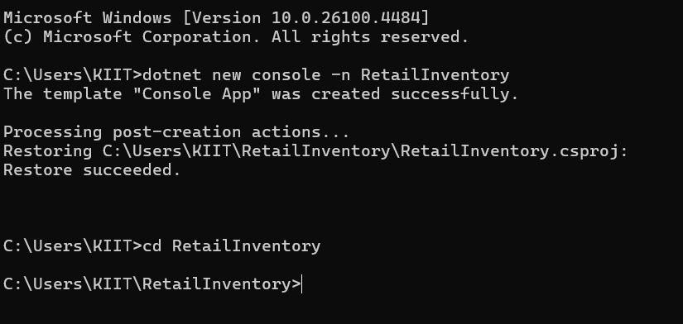

1. **Install EF Core Packages:**

**Solution :**

